REVISION NUMBER-1
Fill in the blanks :-

- The additive inverse of -15 .
- The additive inverse of +29 is .
- The reciprocal of 29 is .
- The reciprocal of 15/8 is .
- The sum of the three angles of a triangle is _______.
- The triangle with 60º, 60º, 60º, is .
- The triangle with 90º,50º, 40º is .
- The triangle with 125º, 30º,25º is .
- The angle equal to its complement is .
- The angle equal to its supplement is .
- The angle equal to its right angle is .
- The supplement of 95º is .
- The complement of 50º is .
14. Sum of two angles is than the other side.
15. Exterior angle is equal to sum of .
16. The sum of two even integers is .
17. The sum of two odd integers is .
18. The sum of one odd and one even integer is .
19. The product of (-3) and (-7) is .
20. The product of (9) and (-13) is .
21. The sum of (-19) and (19) is .
22. The difference of (-25) and (-30) is .
23. Find the value of 13/5 x 4/9 is .
24. Find the value of 2/5 x 5/9 x4/16 is .
25. Convert into lowest terms 5/95 is .

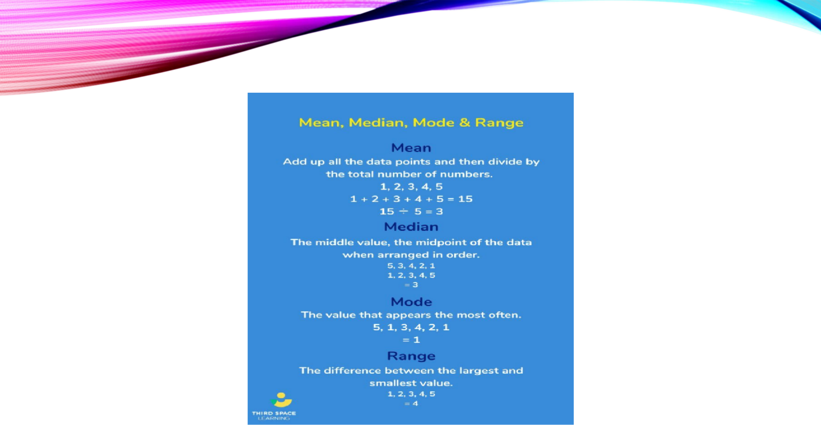
Write the definition
1.Mean
2.Median
3.Mode
4.Range
5.Altitude
6.Median of a triangle.

What is the Median of a Triangle?
The median of a triangle is a line segment that joins one vertex to the midpoint of the opposite side of a triangle. Ob the figure

given below, in which AD is the median, dividing BC into two equal parts, such that, BD = DC.

Every triangle has 3 medians, one from each vertex. The point of concurrency of 3 medians forms the centroid of t triangle

Question no. 3

- Use a protractor to draw angles having the following degree measures
  - 56º
  - 99º
  - 156º
  - 225º
  - 198º

Revision no.2
Solve these Questions
- Write six pairs of integers whose difference is 15?
- Write three pairs of a x b =-18
- Multiply and express as a mixed fraction
  - 17/3 x 4/5
  - 25/5 x 9/8
- Find the mode, median, mean and range of given data (1.) 13,16,12,14,19,12,14,13,14.
(2.) 65,69,67,65,65,62,65,63,61,60,64.
- Write equations for the following statement
  - 10 times z is 90.
  - one fifth of a number y minus 6 gives 7
  - If you take away 7 from 7 times Y you get 70.

6.Write the following equations in statement form
  - 3p+7=34
  - z/3+4=18
  - 5m/8=12

7.Following are the margins of victory in the football matches of league.

1,3,2,5,1,4,6,2,5,2,2,2,4,1,2,3,1,1,2,3,2,6,4,3,2,1,1,4,2,1,5,3,3,2,3,2,4,2,1,2.

Find the mode and range of this data?

Revision no. 3

- Is it possible to have a triangle with following sides?
  - 3cm, 5,cm, 9cm.
  - 10cm,9cm, 15cm.
- If ∠A = 35º and ∠B= 65º, then ∠c=?
- If two interior opposite angles of an exterior angle are 50º and 45º. Then find the exterior angle and the
adjacent interior angle.
- Solve : a) 3x+8=26 b) 8y/3=24
- In the adjoining figure , identify 1.Vertically opposite angles
- Alternate interior angles
- Interior angles on the same side of transversal.
- Pairs of corresponding angles.
- Linear pair or supplementary angles.

- A tower broken at height of 6m from the ground and top touches the ground at a distance of 8m from the base of the tower. Find the original height of the tower?

- Laxmi’s father age is 49 years old. He is 4 years older than 3 times Laxmi’s age. What is Laxmi’s age?

- A vehicle covers a distance of 43.2 km in 2.4 liters of petrol. How much distance will it cover in 1 liter of petrol?

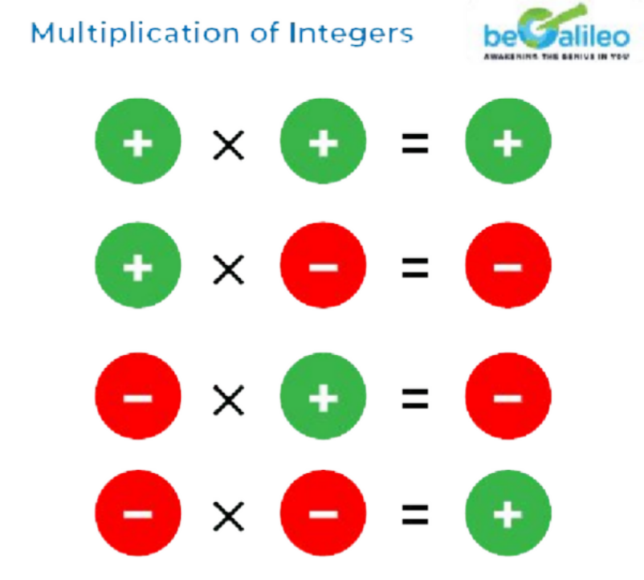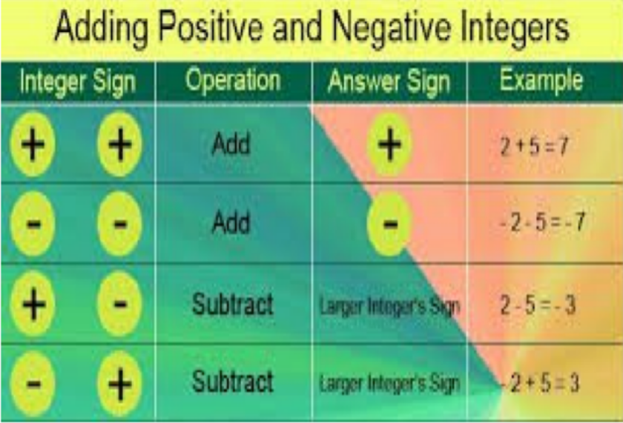

Angle Sum Property
The sum of the three interior angles of any triangle is always

Formula:
∠A+∠B+∠C=180∘

Exterior Angle Property
If one side of a triangle is extended, the exterior angle formed is equal to the sum of the two opposite (remote) interior angles.
- Formula: Exterior Angle = Sum of the two opposite interior angles.

